Sketching and Prototyping: Report

Team #6: Stuck Overflow

Erick Burciaga, Qijan Li, Linoln Nguyen, Nathan Van, Sean Huynh

IN4MATX 131: Human-Computer Interaction

Dr. Stacy Branham

November 18, 2022

# Overview

The user story that we decided to focus on was Leah, an undergraduate student majoring in informatics who wants to find more opportunities to learn and develop human-computer interaction skills at UCI and learn about the types of careers she can pursue with her major so that she can become a more experienced designer and find a career path. The current website failed to support easy navigation through the important resources on the page, and also failed to display important information in an organized, structured layout. We redesigned the home page to be more accessible and easy to navigate with important information displayed in structure. We got rid of the confusing hoverable images with static sections linking to different categories pages, and replaced them with sections that current or prospective Informatics students are looking for: Undergraduate Life, Majors & Courses, Careers, Opportunities, Faculties, and What We Create. We clearly labeled each section with a brief description to help students better understand what they’re going to see under the section. We redesigned some Informatics webpages to focus on the important details of those pages, and clearly divide all key details into subsections within each page for better navigation. Below are the user stories reflecting the problems that Leah is facing, the wireflow Lo-Fi prototypes that illustrate our redesign of some Informatics webpages, and the Webflow Hi-Fi prototypes that will go in detail on these changes.

## User Story

The personas that this user story targets are Taylor, Sia, Sharon, Kevin, and Ken because they all share the commonality of wanting more exposure to HCI opportunities and resources at UCI to learn and develop their skills as well as wanting to better understand potential career options. If users wanted to carry out this user story in the current website, they would first select the “Undergraduate Degrees” tab on the navigation bar. From the drop down menu that appears, they can select “B.S. in Informatics” if they want to learn more about the major and potential careers or they can select “Special Opportunities” if they want to access Handshake which is a site where they can search for and apply to jobs. From the same drop down menu, users can also select “Student Groups” to see the various campus organizations that are related to informatics, human-computer interactions, or computer science in general. The pros of the current design is that the majors offered by the Donald Bren School of Information Computer Science are individually listed out with each having a separate page for its descriptions and requirements. Another pro is that there is a page that lists out the names and descriptions of the campus organizations that students can get involved with and provides links for the organization’s respective site. The cons are that there isn’t much information on the types of careers relating to informatics, which many of the personas expressed frustrations with. The sections for jobs are also awkwardly split across multiple pages, which may be confusing for users who want to access career information, resources, and opportunities all in one location. Some class, campus organizations, and student profile information are outdated as well and may not be useful for users finding relevant and current information.

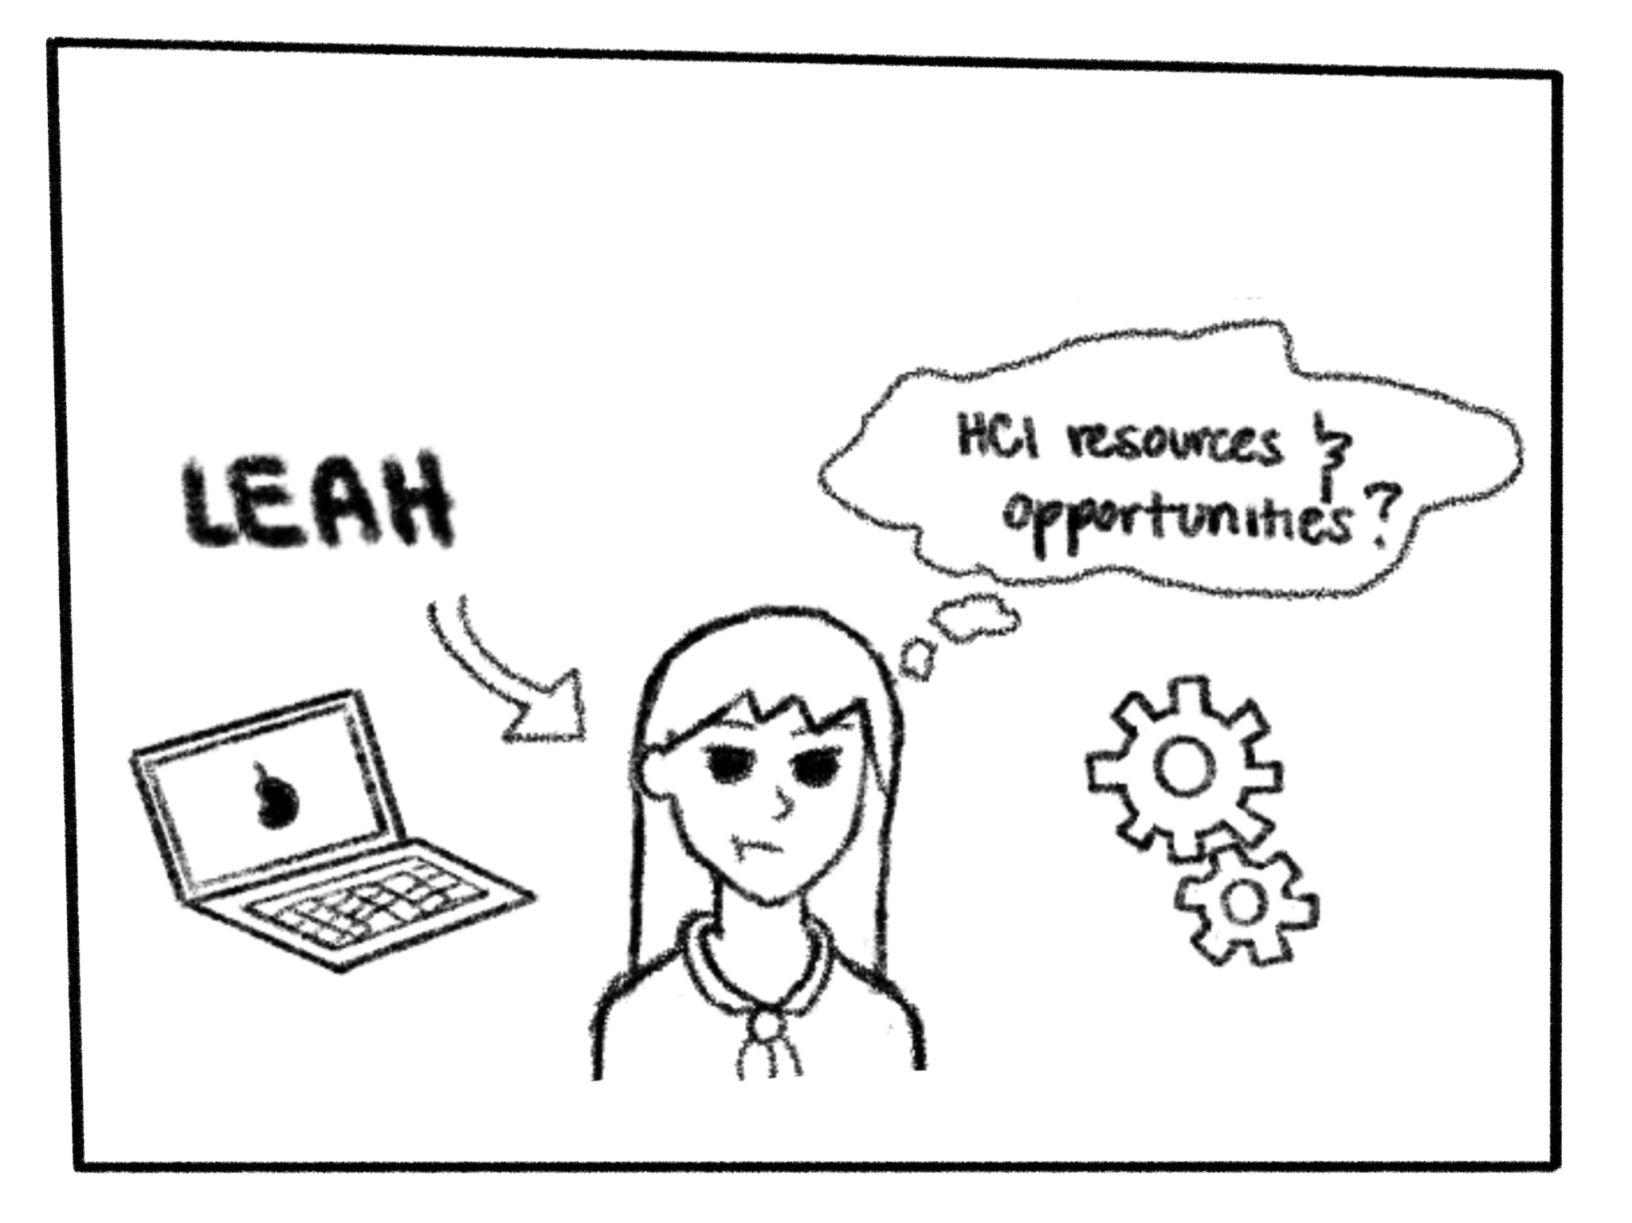

**Figure 1.** Leah is an undergraduate student majoring in informatics and wants to find more opportunities to learn and develop human-computer interaction skills at UCI and learn about the types of careers she can pursue with her major so that she can become a more experienced designer and find a career path. 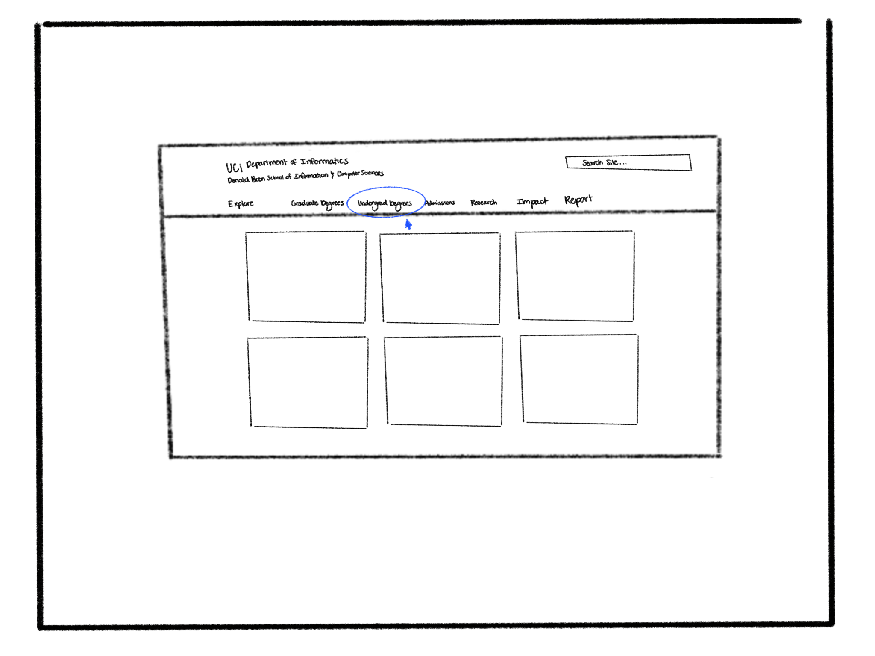

**Figure 2.** Leah would access the UCI informatics website and go to the undergraduate degrees tab to find the information that she is looking for.

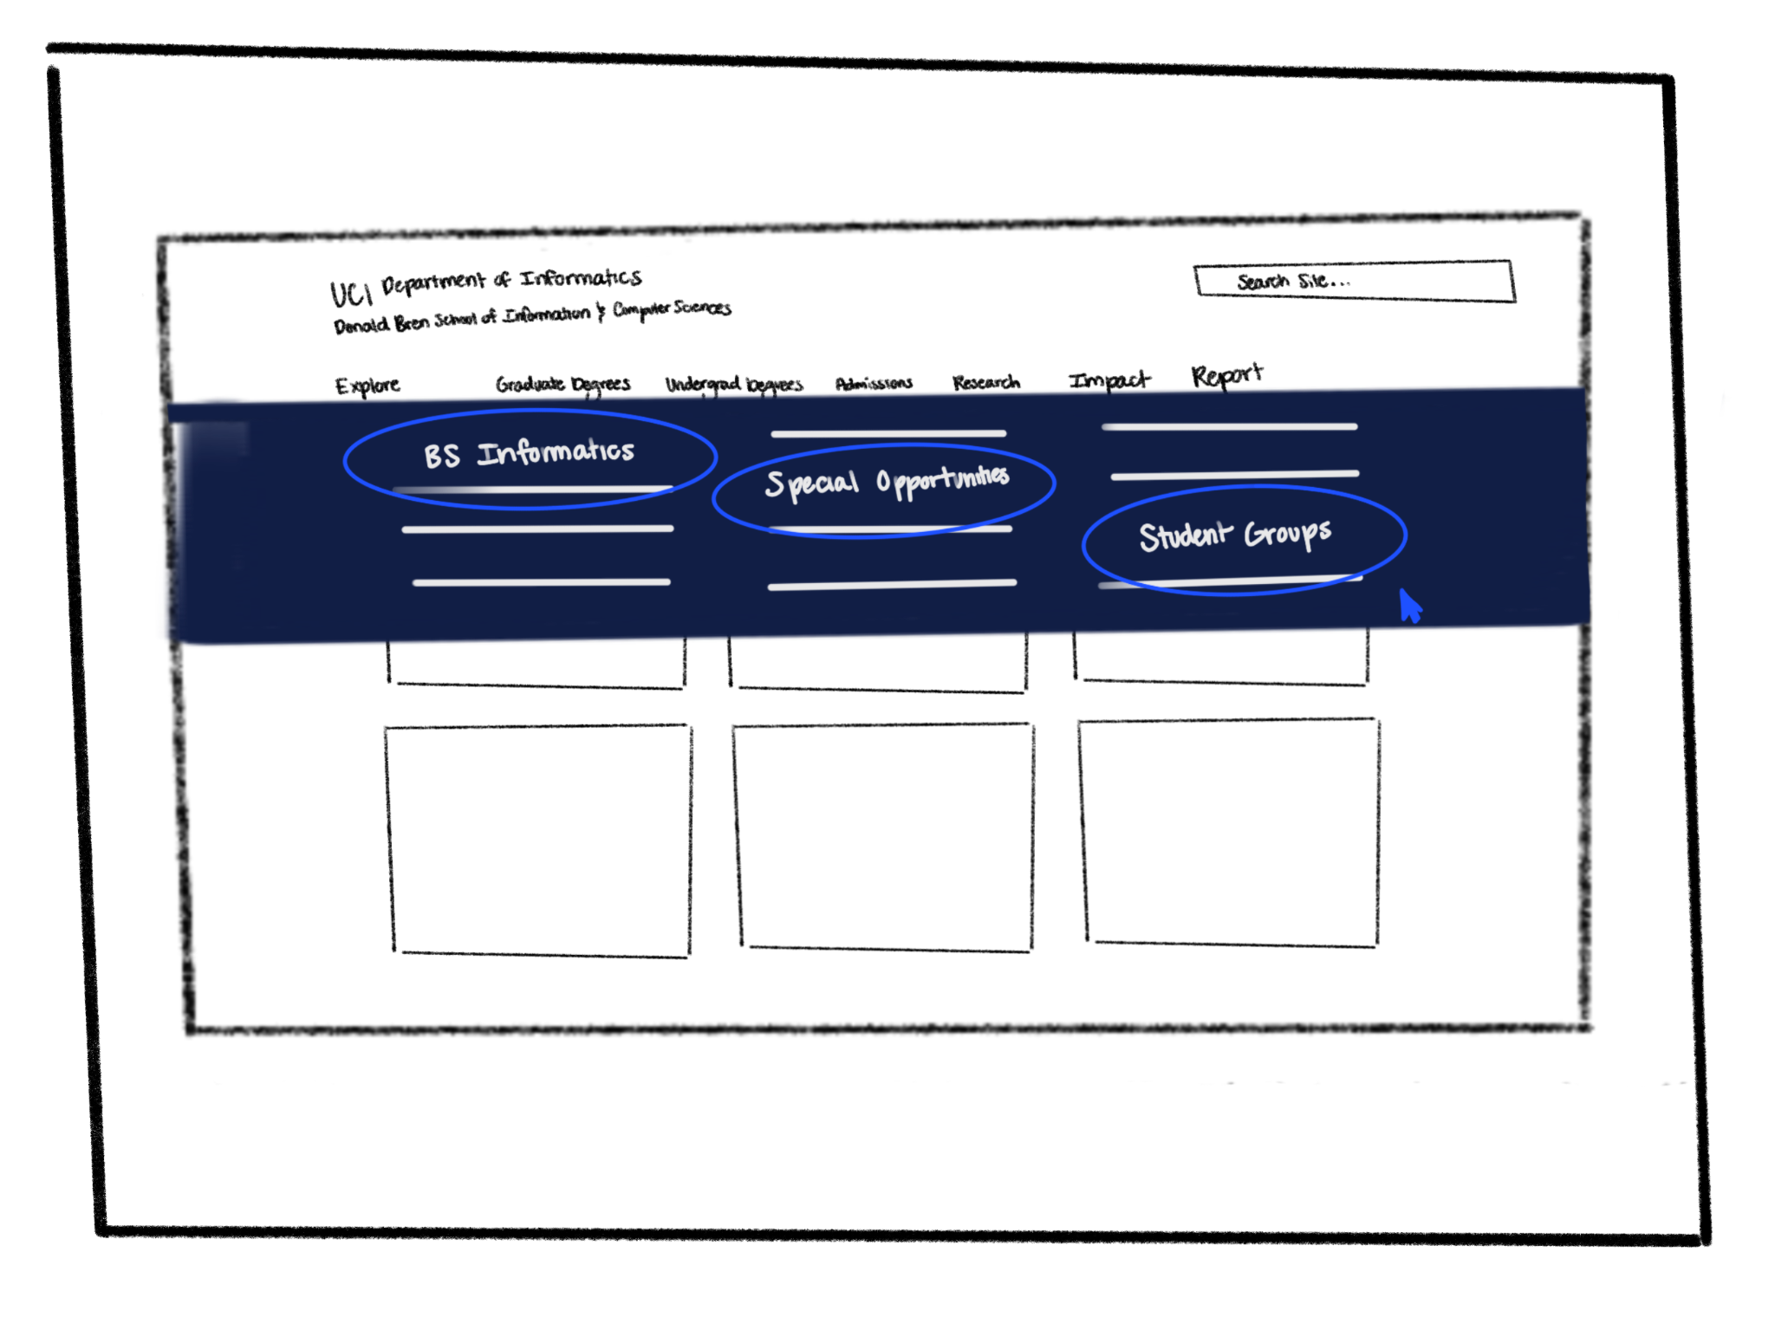

**Figure 3.** From the drop-down menu that appears after she hovers over undergraduate Degrees, she selects B.S. Informatics, special opportunities, and student groups to access more information on the types of campus organizations she can join, what her major description and requirements are, and career resources and opportunities.

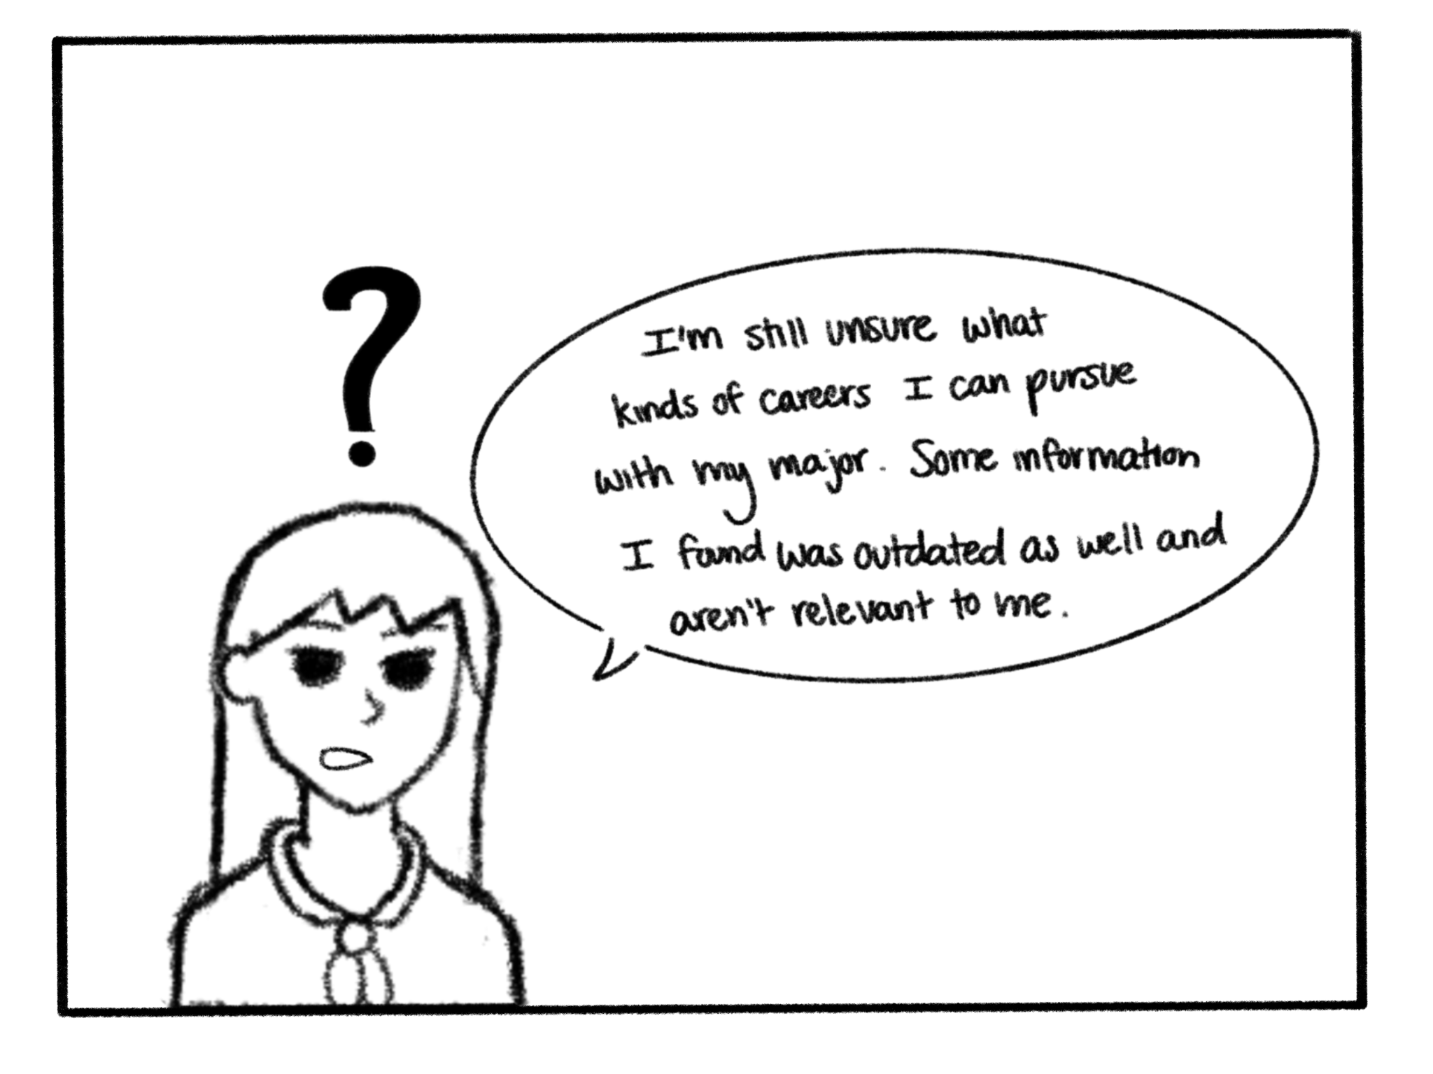

**Figure 4.** After navigating through all the pages, Leah is still confused on the kinds of careers she can pursue, and some information she found was outdated so she is not sure whether it’s accurate and relevant. She wants to join some organizations she found, but doesn’t know if the club still exists or has changed.

## Wireflow Lo-Fi Prototype

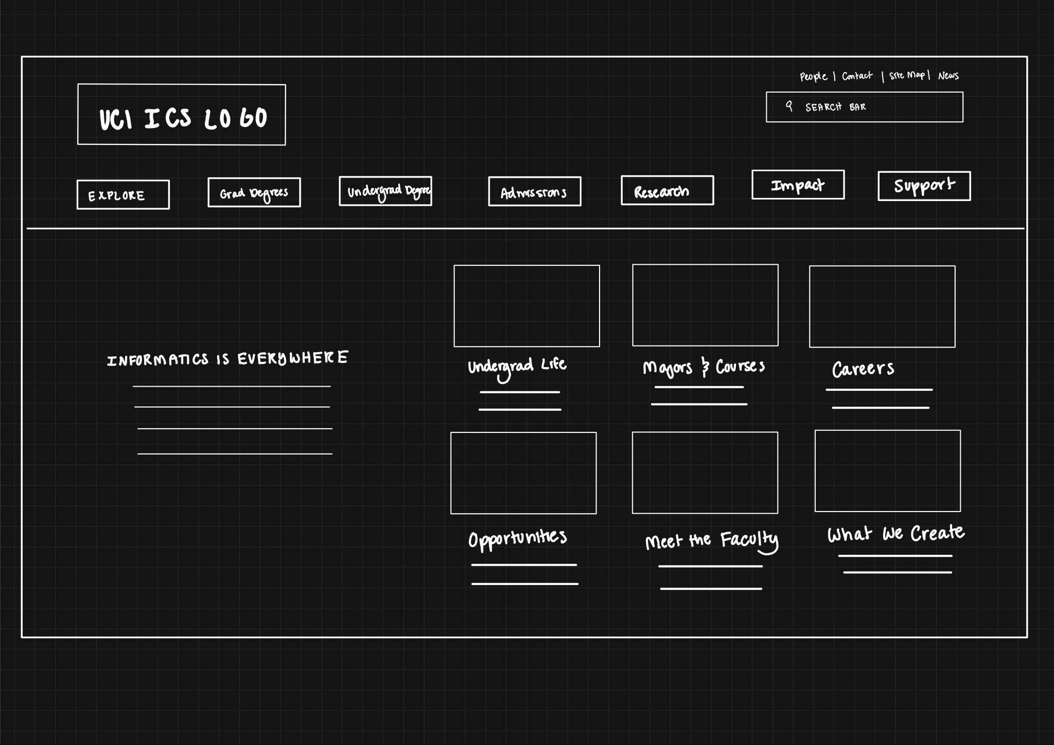

**Figure 5.** The main page has been changed so that when users first access the website, they are no longer confronted with a bunch of images. Previously these images were confusing as they required the user to hover over each one individually to see what they were about and where it would take them when they clicked on it. The user also had to scroll all the way down past the images to read what informatics was about. In our redesign, we reorganized the content on the page so that the description of informatics is to the left of the images and added labels under the images so that users see it right away and understand the content being presented.

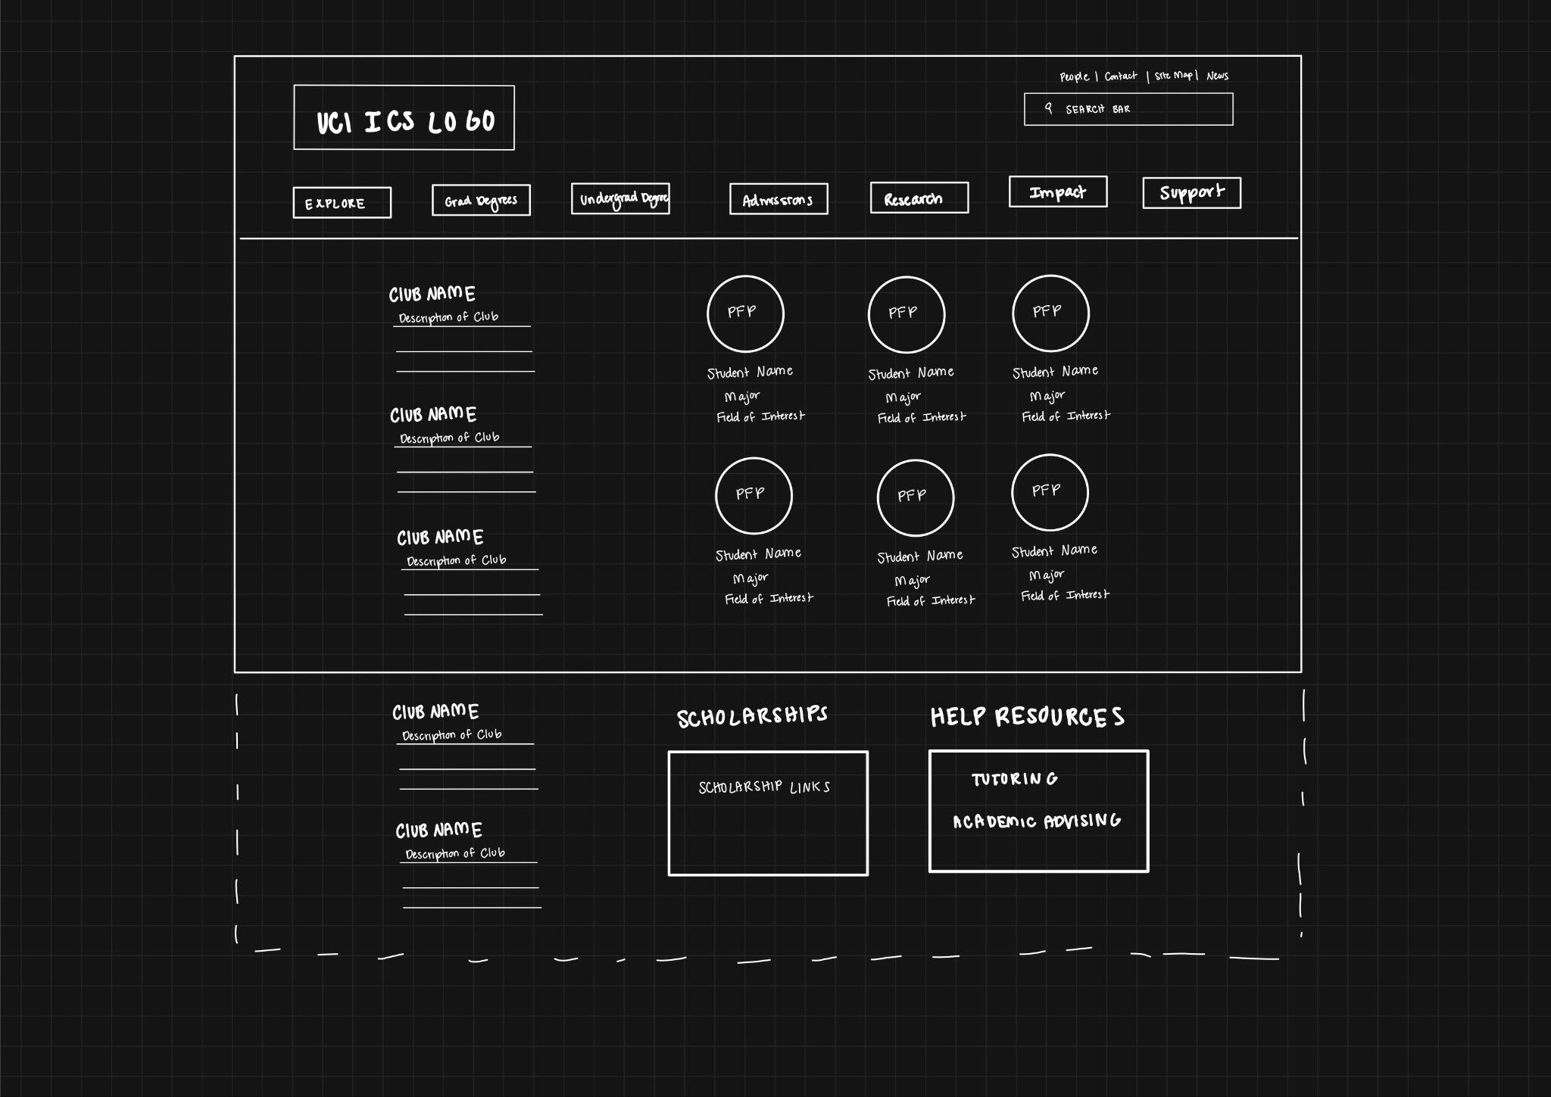

**Figure 6.** Once users clicked on the undergrad life photo or text from the previous page, they would be taken to this page where they can find information on the types of campus organizations available, other undergrads and their college paths, as well as scholarship opportunities and resources like tutoring and academic advising. Each student profile will have its own individual page. This design will be more effective because users can discover the types of organizations available at UCI that can help them develop and improve their technical and professional skills. The description of the organization will also be updated and provide the most current corresponding website or contact information. The major and field of interest under the student profile pictures also allows users to discover different college and career pathways they can take with their major. Users can also see the type of help resources they can get if they are still unsure about what to pursue, what courses to take, or how to improve themselves outside of the classroom with the help resources.

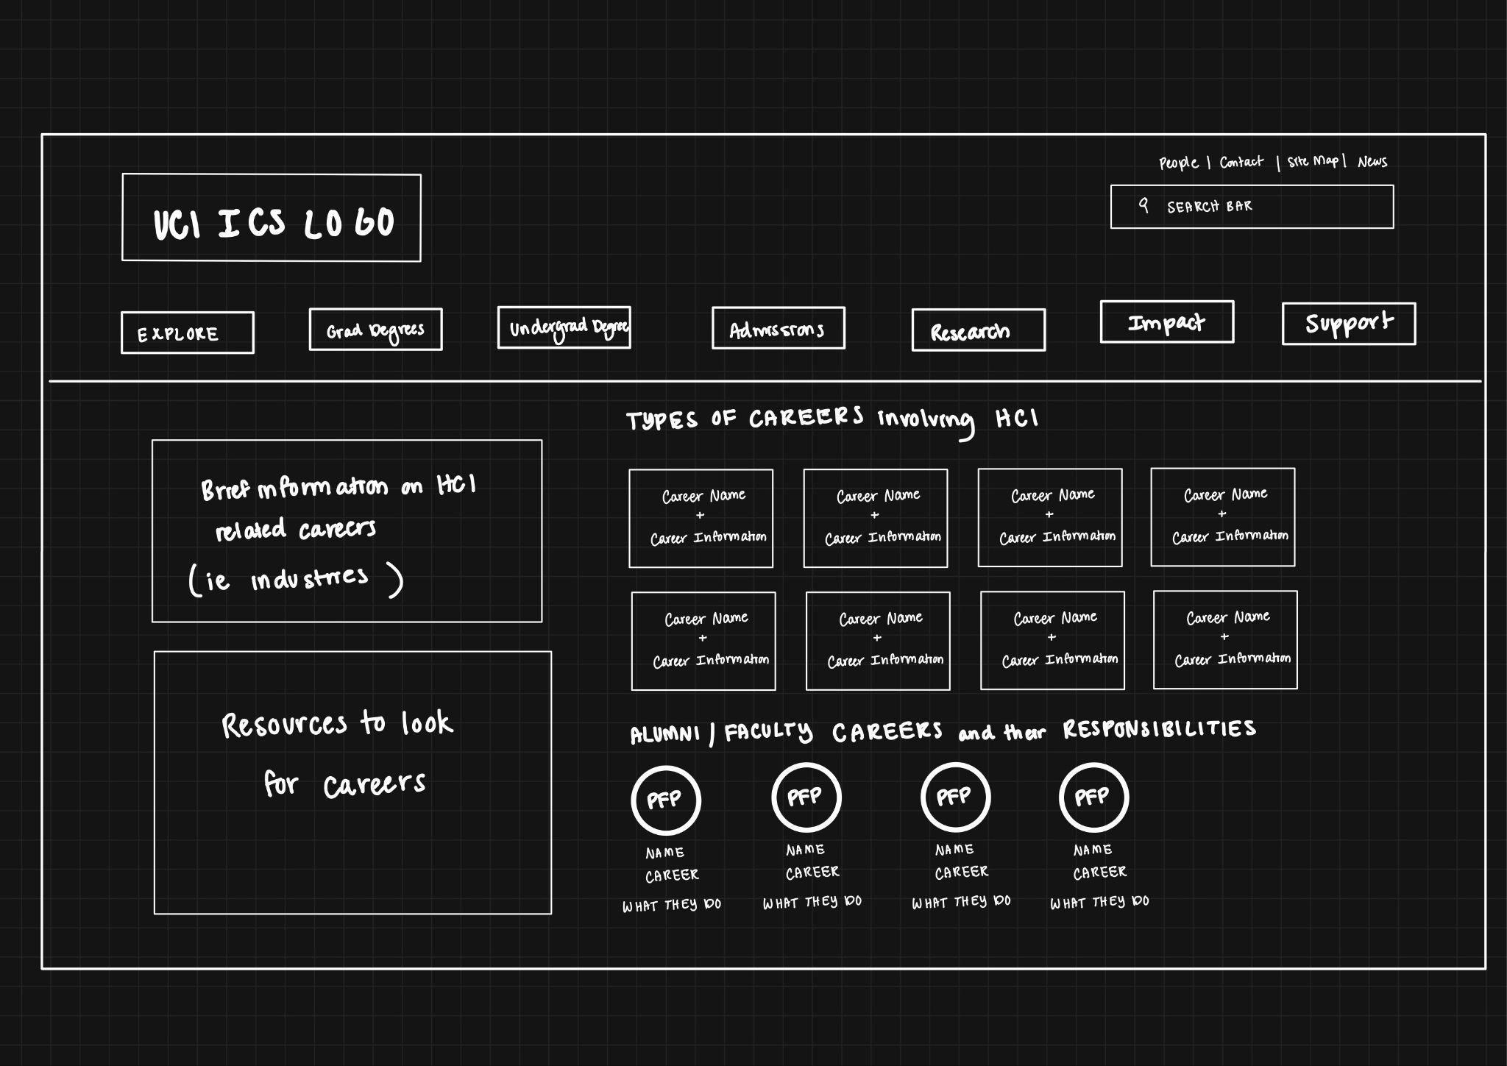

**Figure 7.** From Figure 5, users can click on the careers image or text to access this page where they can learn more about the types of industries and careers that involve HCI. This design will be more effective for our target group because all the resources relating to jobs and careers can be found on one page and more in-depth information and descriptions of careers are available, as many in our target audience were previously struggling with finding careers. Users can also see alumni and faculty profiles and learn more about their jobs and how they use HCI.

**Figure 8.** An alternative to Figure 6 would be to change the student profiles to a calendar with upcoming events relating to HCI that students can participate in to learn or get hands-on experience. 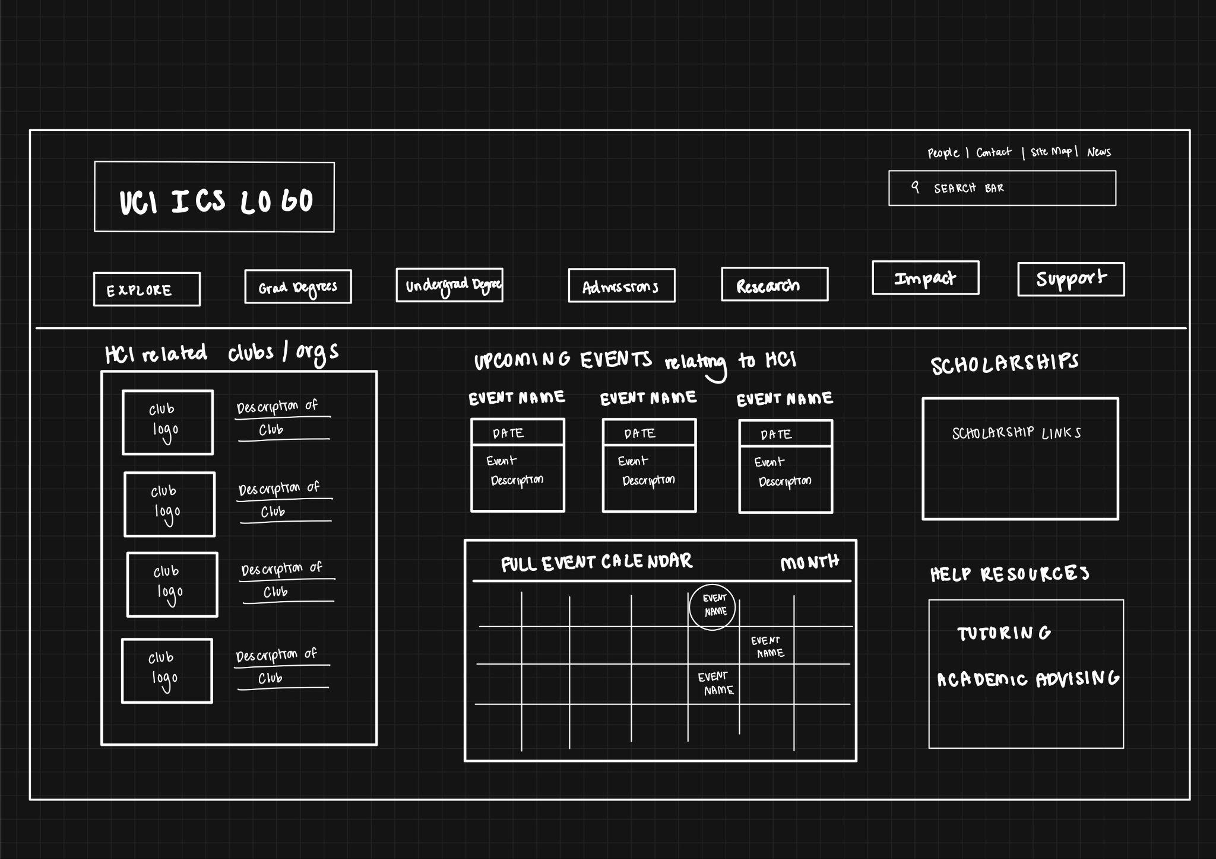

## Webflow Hi-Fi Prototype

Read Only URL: <https://preview.webflow.com/preview/ericks-fresh-site-c7c010?utm_medium=preview_link&utm_source=dashboard&utm_content=ericks-fresh-site-c7c010&preview=d16cfb36bb29fba932765547771c800a&workflow=preview> 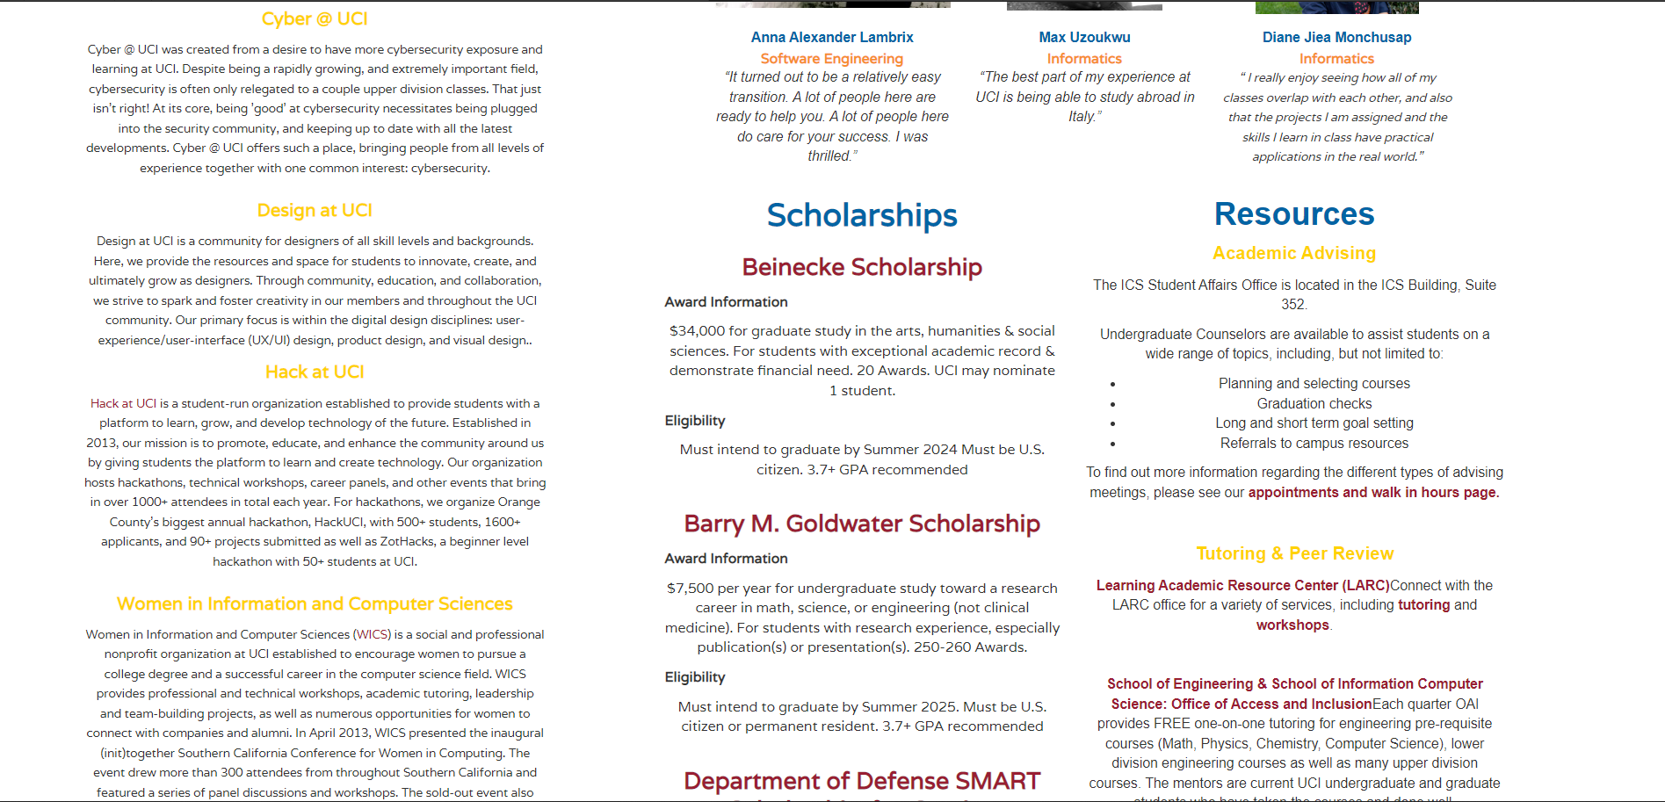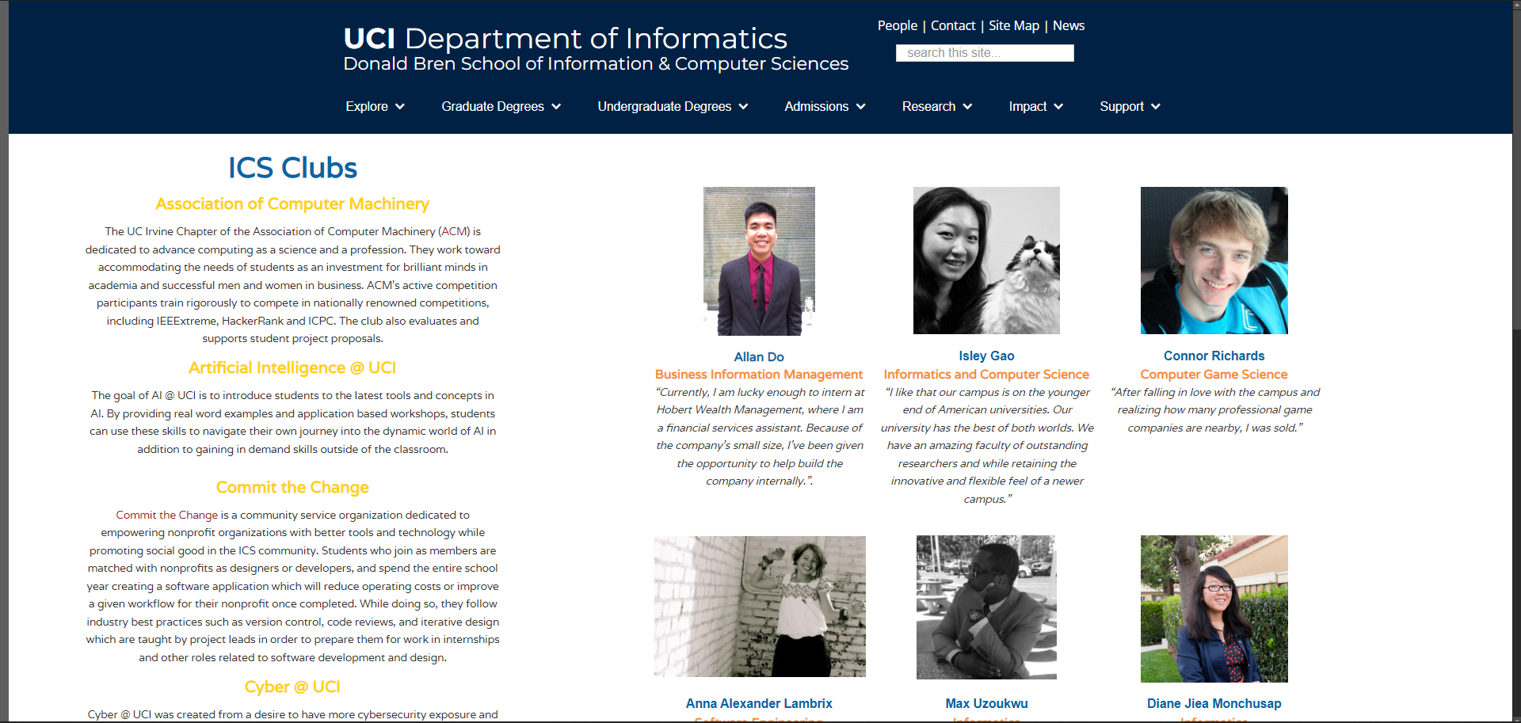

We designed this prototype to efficiently address the issues we had previously raised, so that the user experience of our UCI students could be greatly improved. Through the personas that this user story targets students are the ones who want to use this site to learn more about UCI resources and opportunities to hone their skills and hopefully better understand potential career options and campus engagement. Initially, our prototype altered the main page in a relatively friendly manner by removing a number of photo panels from the page's cover. This allowed the user to be immediately drawn to the main content we have marked directly and understand the content displayed as quickly as possible without being confused. Users may quickly navigate through the material on the website in our revised interface to locate what they need. Through a revamped layout, students can access information about school organizations while still having a distinct page for each student's profile. This innovative design may successfully reflect the organizational character of UCI and is a significant increase in the user experience. It highlights undergraduate-related opportunities and resources, including tutoring and academic counseling. This straightforward design allows student users to locate their own material and favorite items, which helps users more effectively filter out unimportant and distracting information and increases productivity. More significantly, the interface promotes the direct link between the university and students and increases student engagement with the campus. Additionally, our prototype effectively applies the relevance of HCI, and the new user interface enables us to connect students with pertinent data on their career prospects and involvement on campus.

## Conclusion

For the sketching and prototyping, our group first read through all the user personas and figured out what challenges and frustrations were shared and how we wanted to help solve them with our redesign. We then looked at the current ICS website and figured out what worked and weren't so effective in assisting users find the information and resources they needed. From there we brainstormed potential solutions to combine, reorganize, and restyle existing content so that users have an easier time navigating the site and locating what they want to find. We wanted our design to be simple, accessible, and easy to understand. We mainly focused on grouping certain information together so that they weren’t on separate pages as well as adjusting the layout of the page so users can quickly see what type of content is being presented. Our next step is to create a website from the prototype with working links and selectable images and profiles and simulate it according to how the users would want to navigate through the website. After multiple usability tests, we would take notes and create more iterations to address the issues users may face.

## Appendix

### Group Work Distribution

Sean Huynh - User story board and Lo-Fi Wireframes

Erick Burciaga - Webflow Hi-Fi Prototype

Lincoln Nguyen - Conclusion and Accessibility

Nathan Van - Overview and Extra 5%

Qijan Li - Hi-Fi Report Section

### Extra 5% (Optional)

We produced more wireflow designs than required of different Informatics webpages. We provided an alternative to the undergrad life page that had new content in the form of a calendar with upcoming HCI related events as a proposal solution to help solve the issue users had of not being able to find other resources on campus to learn and get hands-on experience with HCI.